Water pollution
Institutional affiliation
Name of lecturer
Name of student
Submission date

Water pollution
Water pollution is defined as water bodies, for example, lakes, oceans, and rivers that are affected by pollutants that are discharged in water masses, whether this happens directly or indirectly. Pollutants include oil leaks, sewage and wastewater, and industrial waste.
One of the main causes of water pollution is oil leaks. Oil pollution occurs when oil spills accidentally from tanks that are on ships that travel from port to port. Ships pollute ocean water by leaking oil into it, resulting in major damage to the water and creatures living in it. Accidental oil leaks have caused a lot of beaches to be evacuated and many animals to die and be endangered. Petroleum is a toxic component and causes a huge problem for the ecosystem. Oil does not dissolve in water and forms a thick substance.
The second cause of water pollution is sewage and wastewater. With many people on our planet, sewage waste is a problem. Sewage comes from households and factories when you flush the toilet, and there is still waste to dispose of. Sewage can be a problem when people flush chemicals down the toilet. Sewage water is transferred into the rivers with no proper treatment, or if it is treated, it is done in a very poor manner. On some occasions, sewage waste is pumped into the sea without it being treated properly.
Finally, industrial waste also causes water pollution. Industrial waste from factories that contains toxic chemicals and pollutants pollutes water bodies. Many factories and industries do not have a proper way to dispose of their waste, so they just drain them into our seas and oceans. These toxic chemicals can change the color of the water and can cause the water to be harmful to us as humans and for the sea creatures.
Water pollution has great impacts to living things. When oil spills in to the water bodies, it leads to poor air circulation in the water which leads to death of aquatic animals. Water creatures such as dolphins, crabs, fish, sea birds and sea gulls end up in the sea beaches. As such, this may interfere with food chain and therefore, reduce the food substances for human consumption. Human beings can get diseases such as hepatitis due to consumption of seafood that has been contaminated by the water pollutants. Also, due to the water pollution, there have been outbreaks of cholera in some countries due to drinking of contaminated water. Water pollution also causes destruction of the bionetwork in the areas the pollution occurs. Living organisms depend on each other and thus destruction of one species affects the other living organisms. Also, it may lead to financial constrains to the country. Governments may spend large amounts of money in the attempt to alleviate the condition and thus creating a financial constrain. There are revenues acquired through fish. Water pollution causes death of fish and thus reducing the revenues earned from such economic practices.
To control water pollution measures have to be taken and approaches developed to ensure effective control of the problem. As such, regulations, by-laws and water management procedures should be developed. The regulations and by-laws can be legislated and amended within a short notice to influence specific cases. The management regulations will set the guidelines and practices that should be taken to ensure responsible management of water pollution. Also, setting water quality standards will regulate the deposition of waste products to water bodies. This will be done through ensuring fixed emission standards and ensuring environmental quality approaches. The use of economic instruments such as resources pricing, product charges and effluent charges may help fix the problem. Also, economic tool like non-compliance levies can be levied to institutions and companies to ensure they comply with the set standards.
Goals and Objectives
Goal #1: Maintenance – Oil pollution occurs when oil spills accidentally from tanks that are on ships that travel from port to port. Tighten bolts on engines to prevent oil leaks. Bolts can shake loose with engine use. The oil safety valve should be installed on the supply line of your heating system if you do not already have one. The safety valve will automatically shut off the oil supply if the line breaks. Regular checks to the ship engines that take a span of 3 months should be observed.
Goal #2: Proper sewage treatment – Sewage and wastewater that comes from households and factories should be treated to avoid pollution when disposed to large water bodies. When you flush the toilet, there is still waste to dispose of. Eco-friendly wastewater treatment options, such as recycling sewage sludge to carbon-phosphorous fertilizer, are other solutions. By doing this, we will achieve the goal of preventing water pollution. The treatment should be done on a daily basis to prevent any pollution that might be from factories or households.
Goal #3: Cut down on industry waste – Industrial waste from factories that contain toxic chemicals and pollutants that can be hazardous. Industry and manufacturers must cut down on waste and contain landfills, so they don't spill into the ocean. This goal will help prevent the problem. The factories should take control of waste products on all the waste they produce on a daily basis.

Roster of Participants
The group was carefully chosen after a series of interviews and a lot of consideration. Every member of this group is much dictated to our cause, which is to help reduce water pollution. With that in mind, our team works extremely hard to achieve our ultimate goal. We have three main problems oil spills, sewage and wastewater, and industrial waste.
Each of these problems has its team, which works together with organizations and industries by having liaisons. For example, we have liaisons working inside factories to help us help them go through the proper process of getting rid of their waste instead of dumping them. By having liaisons, we can communicate with the cooperation and create a close working relationship. Every team has a creative analyst that helps provide us with new and creative ways to solve the problem. Also, we have a data analyst that analyzes the given information to help our team. Also, every department has a chief that encourages the team and makes sure everything is running smoothly. Finally, the head chairwoman is the go-to for any problems that might occur and needs to be resolved; mostly, the analysts are government verified analyst. Also, the engineers to investigate the engines should be under contract with the federal government to ensure the quality of the inspections.
Every department team will work together to solve the problems regarding water pollution. All department chiefs will gather and have a meeting with the chairwoman and discuss all the issues that need to be discussed regularly. E-mail is an essential way to communications with each other in our organization. The regulatory bodies should provide regular reports to the National Oceanic and Atmospheric Administration (NOAA) and Environmental Protection Agencies (EPA). At least, the agencies should have representatives from these agencies.
NAME | ORGANIZATION | TITLE | PHONE | EMAIL ADDRESS
Jo Wilson | BP Organization | Oil department chief | (402)-111-1111 | JW@gmail.com
Mike smith | BP Organization | Oil liaison | (402)-222-2222 | MS1@gmail.com
Kensi Blye | Dell EMC | Creative analysts | (402)-333-3333 | KB@gmail.com
Jack Simon | Dell EMC | Data analysts | (402)-444-4444 | JS@gmail.com
Nell Jones | Surfers Against Sewage | Sewage and wastewater chief | (402)-555-5555 | NJ@gmail.com
Eric Beal | Surfers Against Sewage | Sewage and wastewater liaison | (402)-666-6666 | EB@gmail.com
Owen Granger | Dell EMC | Creative analysts | (402)-777-7777 | OG@gmail.com
Antony Dinozzo | Dell EMC | Data analysts | (402)-888-8888 | Ad@gmail.com
Ziva David | National Waste and Recycling | Industrial waste chief | (402)-999-9999 | ZD@gmail.com
Patrick Jane | National Waste and Recycling | Industrial waste liaison | (402)-000-0000 | PJ@gmail.com
Alex Kerev | Dell EMC | Data analysts | (402)-101-1010 | AK@gmail.com
Mark Sloan | Dell EMC | Creative analysts | (402)-000-0001 | MS@gmail.com
Callie Torres |  | Head chairwoman | (402)-000-0002 | CT@gmail.com

Agenda
Our organization holds the meetings at the same time and place each week. We send the agenda out beforehand. We identify what we hope to accomplish from these meetings. As an organization, we try our best to recognize progress made by team efforts and not only individuals because when we only recognize one individual for a team effort, this will cause resentment among the team members that have not been recognized. The agenda is placed where everyone has access, review, and contributes.

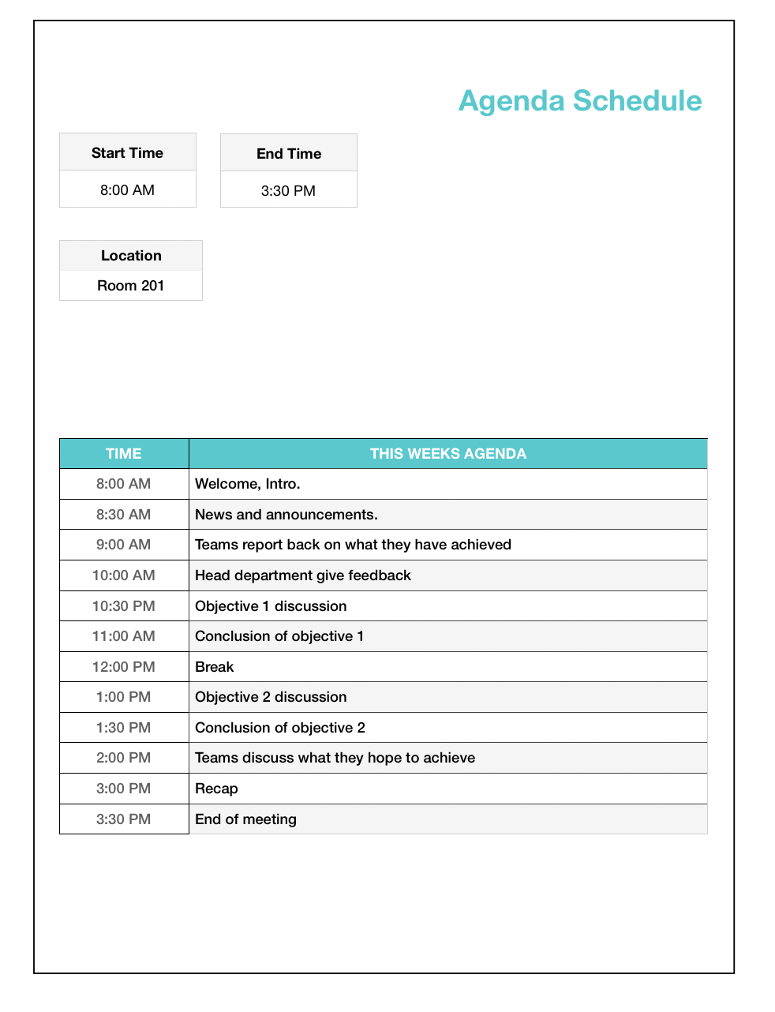

Activity #1: Activity Name
TOOL/METHOD: Brainstorming
PARTICIPANTS: All teams
MATERIALS: To complete the tasks, we need all the information gathered by the team beforehand.
TIME ALLOTTED: 60 minutes (1:00 PM – 2:00 PM)
INSTRUCTIONS:
First, we need to know what our objective is; in our case, our objective is to stop water pollution. The teams will get together and discuss this issue and every aspect of this issue. After that, the teams will identify the problems that contribute to water pollution oil leaks, industrial waste act. Each team will work and brainstorm ideas and solutions to stop water pollution. Brainstorming is a great way to figure out how to improve a system or solve a problem. The teams will conduct brainstorming sessions. They will meet and get together and come up with ideas on how to deal with our issue. It's all about getting creative thoughts flowing without shooting down anyone's ideas.
After the brainstorming session is over, the teams will be divided into groups every group will deal with a specific solution to our problem, which is water pollution. The group leaders will get together and clarify their group's task, so everyone knows what they are doing. All of the groups and leaders will come together and discuss their findings. Then the groups will prioritize the solutions and see what should be done first. Finally, we will deliver the solution and work on them. The major question in this process is what challenges will be faced in the process of implementing the program? Also, what are the possible solutions to these challenges? The third question is how the program will help solve the problem of water pollution.
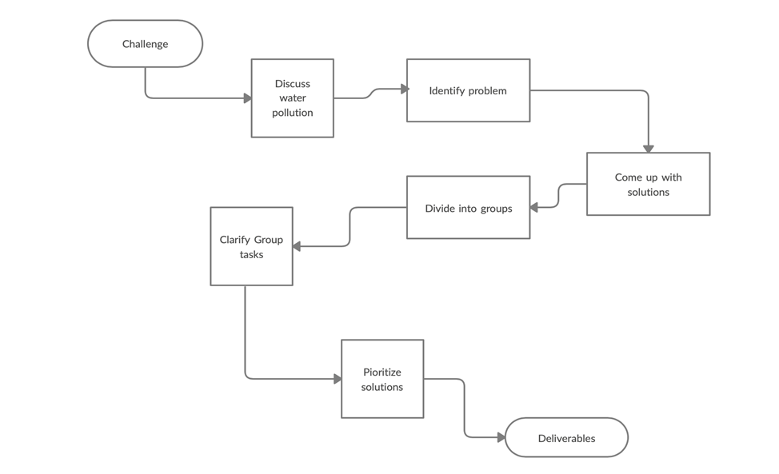
Activity #2
TOOL/METHOD: Brainstorming/Mind Mapping
PARTICIPANTS: All teams
MATERIALS: To complete the tasks, we need all the information gathered by the team beforehand.
TIME ALLOTTED: 60 minutes (1:00 PM – 2:00 PM)
INSTRUCTIONS:
The room setting and atmosphere is very important to us as an organization. The room will have just enough space, so team members aren't crowded, but the room will not too large that the empty space sucks all the energy out of the room. The room will be arranged so that the chairs in a u-shape. Communication is the key to a successful meeting, and we want all the members to be able to see and hear each other. A whiteboard will be placed at the opening so all members can see and focus on the task at hand. Since our meeting will last for an hour, the chairs will have wheels on them. Armrests are good and extra padding for comfort. There will be water bottles on the tables in front of each chair. Given the time of our meeting, which is close to lunchtime, we will provide drinks as well as snacks such as; bagels, muffins, cookies, cheese, and crackers. Pens and notepads will also be provided and placed on the table. An essential oil diffuser will be in the room with scents such as jasmine and lavender to stimulate creativity, concentration, and relieve stress.
A brainstorm meeting is a long and free form meeting design. Excellent for discussing topics, ideas, and solutions. We encourage all our team members to respect everyone's ideas and not to downgrade someone's ideas. The main aim is to get creative thoughts flowing without shooting down anyone's ideas. The teams will be using the whiteboard to draw a simple mind map; so everyone can see their ideas. A mind map is a graphical way to represent ideas and concepts from the brainstorming session. It is a great visual thinking tool that helps to structure information, generating new ideas, and identifying relationships among different data and information. Making a mind map is an excellent way for the teams to be able to sort through their thoughts and ideas. Mind maps allow team members to quickly generate creative and unique ideas in a short time period. It gives them the freedom they need when brainstorming so that the flow of ideas is not blocked. After the brainstorming and mind mapping session is over, all of the groups and leaders will discuss their ideas and solutions and what they will do with what they have. Communication is a crucial key for everything to run smoothly. The groups will prioritize the solutions and see what should be done first. Finally, we will deliver the solution and work on solving this problematic issue. The process has answered what the end product of the process is. The participants in the process will work towards minimizing enhancing the effectiveness of the process.

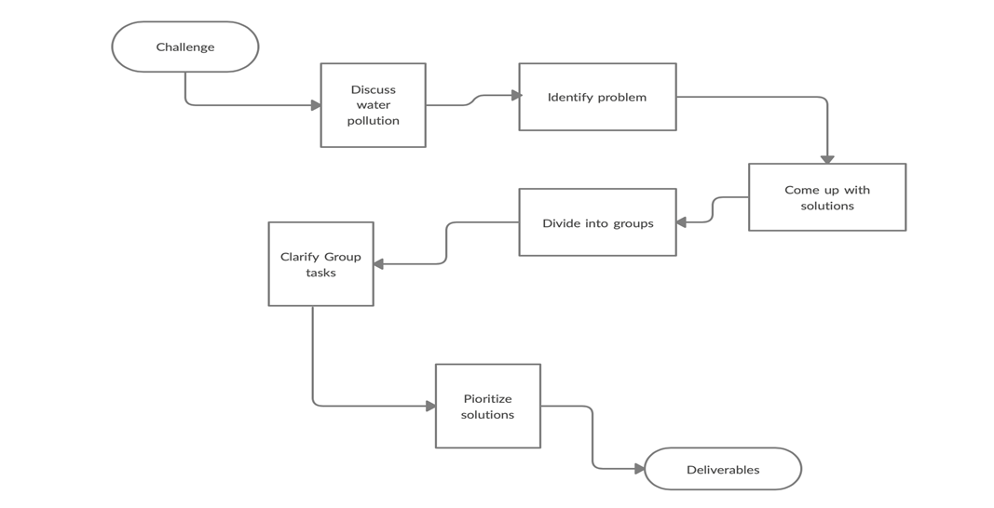
Activity #3
TOOL/METHOD: Brainstorming/Mind Mapping
PARTICIPANTS: All teams
MATERIALS: To complete the tasks, we need all the information gathered by the team beforehand.
TIME ALLOTTED: 60 minutes (1:00 PM – 2:00 PM)
INSTRUCTIONS:
The room setting and atmosphere is very important to us as an organization. The room will have just enough space, so team members aren't crowded, but the room will not too large that the empty space sucks all the energy out of the room. The room will be arranged so that the chairs in a u-shape. Communication is the key to a successful meeting, and we want all the members to be able to see and hear each other. A whiteboard will be placed at the opening so all members can see and focus on the task at hand. Since our meeting will last for an hour, the chairs will have wheels on them, and armrests are good and extra padding for comfort. There will be water bottles on the tables in front of each chair. Given the time of our meeting, which is close to lunchtime, we will provide drinks as well as snacks such as; bagels, muffins, cookies, cheese, and crackers. Pens and notepads will also be provided and placed on the table. An essential oil diffuser will be in the room with scents such as jasmine and lavender to stimulate creativity, concentration, and relieve stress.
A brainstorm meeting is a long and free form meeting design. Excellent for discussing topics, ideas, and solutions. We encourage all our Team members to respect everyone's ideas and not to downgrade someone's ideas. The main aim is to get creative thoughts flowing without shooting down anyone's ideas. The teams will be using the whiteboard to draw a simple mind map; so everyone can see their ideas. A mind map is a graphical way to represent ideas and concepts from the brainstorming session. It is a great visual thinking tool that helps to structure information, generating new ideas, and identifying relationships among different data and information.
Making a mind map is an excellent way for the teams to be able to sort through their thoughts and ideas. Mind maps allow team members to quickly generate creative and unique ideas in a short time period. It gives them the freedom they need when brainstorming so that the flow of ideas is not blocked. After the brainstorming and mind mapping session is over, all of the groups and leaders will discuss their ideas and solutions and what they will do with what they have. Communication is a crucial key for everything to run smoothly. The groups will prioritize the solutions and see what should be done first. Finally, we will deliver the solution and work on solving this problematic issue.
Our main issue/question is, "How to clean our water, recourse?" The team members will spend half an hour brainstorming answers to this question, and then they will spend another half an hour drawing a mind map on a whiteboard using a colored marker to make it easy to read and more interesting. Then each team will go to the front of the meeting room and present and show
Their ideas/mind maps to the whole team using the whiteboard. Anyone how has a question or wants to contribute can do so by waiting until the presenter is finished taking and then say what they wish to say. Ideally, we would like everyone to concentrate on whoever is presenting. Contributing in meetings does not only involve positive contributions, anyone that is able to highlight any problem or issue can and should use the meeting as a way of addressing them.
Our budget for this meeting is $350, and any remaining money from this meeting will go into next week's meeting. The meeting room does not cost anything since it is in our company building. That being said, there will be no transportation fee because everyone who will be attending this meeting will be from our company. Drinks and snacks will cost approximately $100, the essential oil diffuser and essential oil will cost $80. Postage and Printing such as pens, notepads, and whiteboards will cost $100. This brings the total paid for this meeting to $280, with $70 left.
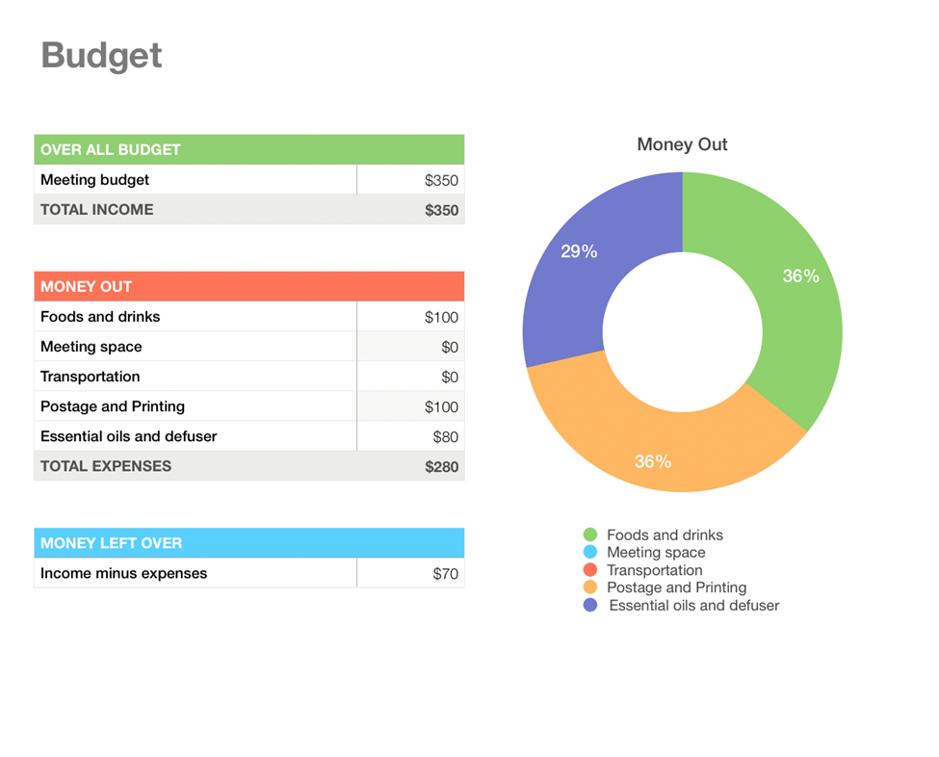

Appendixes
Appendix 1: Example of water population

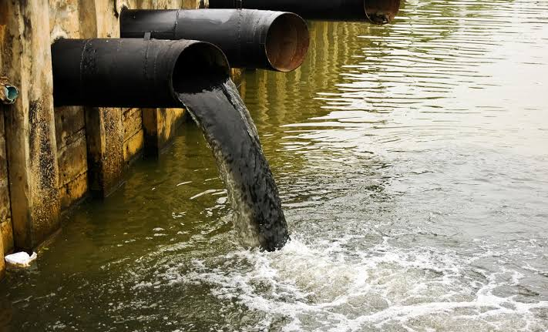
Liquid waste materials from industries cause pollution when disposed to water bodies. These wastes should treated to before the waste is disposed in water bodies.

Appendix 2: Effects of water pollution
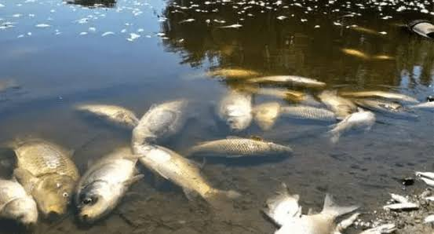
Oil spillage causes death of aquatic animals and thus hinder the growth marine life. This affects the ecosystem.

Appendix 3: How is water pollution in America?

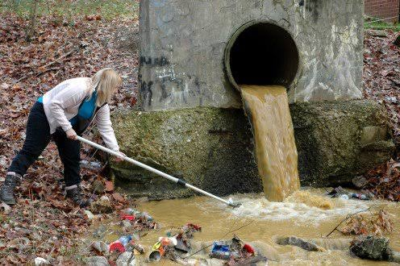
Water pollution in the United States of American is worsening every day. This is an issue that needs to be addressed to avoid future problems.

